# Dali Shaxi

Shaxi is a thousand-year-old town in Dali, Yunnan. It is located along the Ancient Tea-Horse Road and is the only surviving ancient market on the Tea-Horse Road. Shaxi ancient town has preserved its original appearance and people here live a simple and peaceful life...



(一个视频，沙溪概览）

* One on one personalized course
* Immersive experiences of culture, scenery and local life
* Excellent tutors with professional certificates and rich teaching experience
* 3 meals Monday to Friday and accommodation

**One on one personalized course**

Course type available：

🗹 one on one intensive course for all language level/goals and culture demand

🗹 one on one Travel Chinese

🗹 one on one HSK preparation

We will **tailor your course** to your personal demand and language level, match you with the tutor who is most suitable for you as well.

Classes are held from every Monday to Friday. You can choose to study **4 hours, 5 hours or 6 hours** per day. The daily class schedule is very **flexible** and can be adjusted according to your dynamic requirements.

Your tutor will not only help you achieve your learning goals, but also create rich **real-world** contexts for you and accompany you to **practice** in all-Chinese speaking environment, truly **combining learning with application** and naturally **integrating into the local life**.

**Immersive experiences of culture, scenery and local life**

Feel the temperature of books in Xianfeng Bookstore (the Librairie Avant-garde) nestled in the countryside

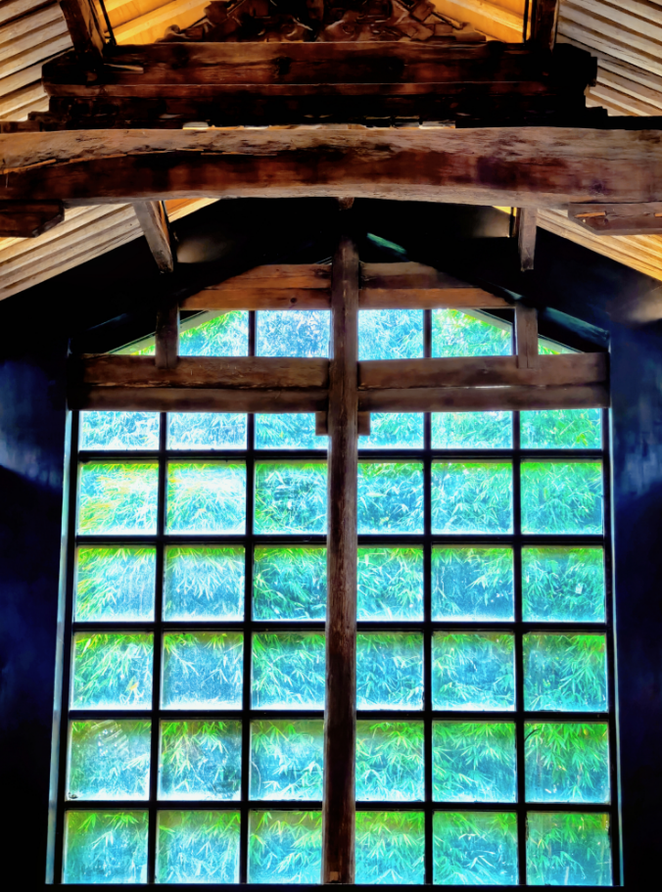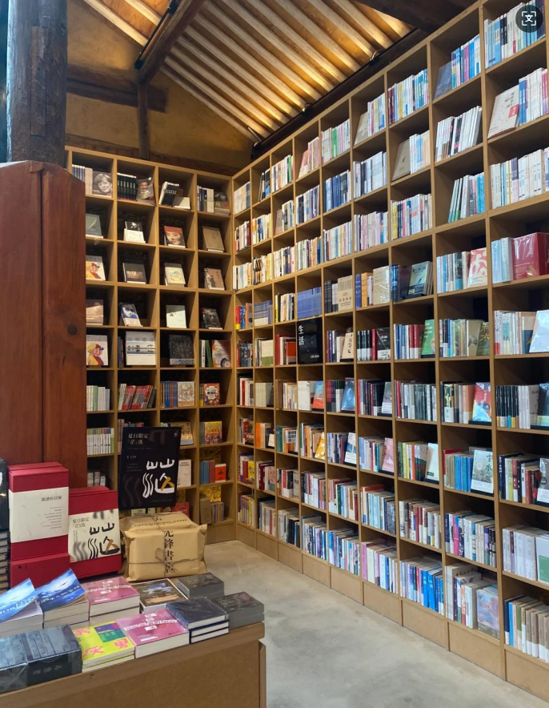

Meet distinctive cultural and creative works

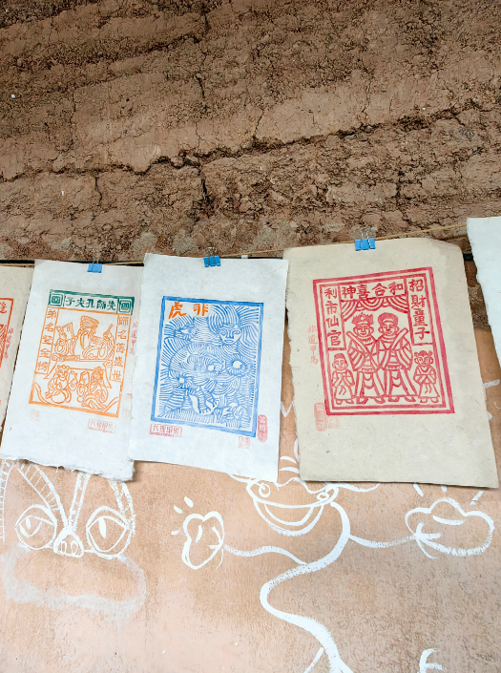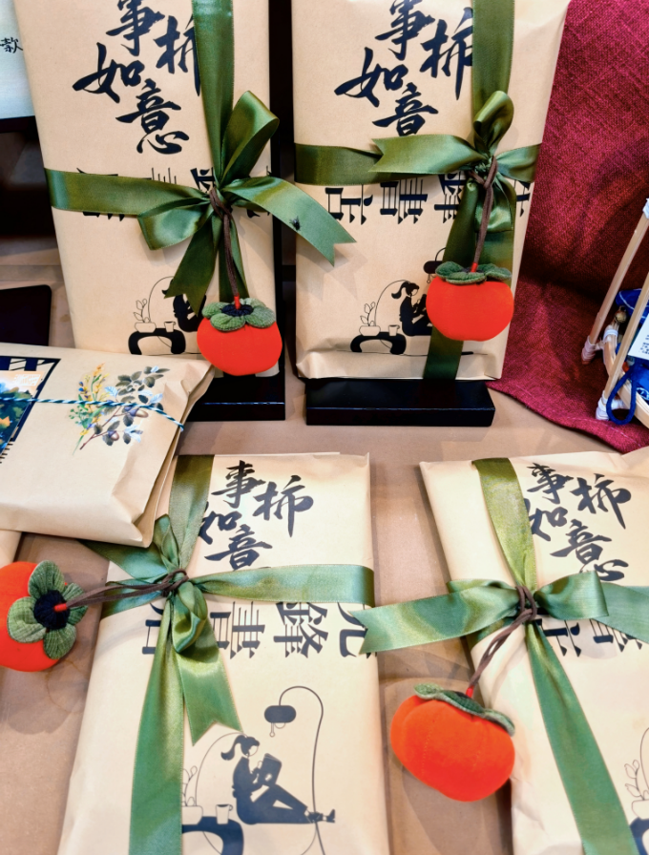

Experience ancient art and take your unique work back home

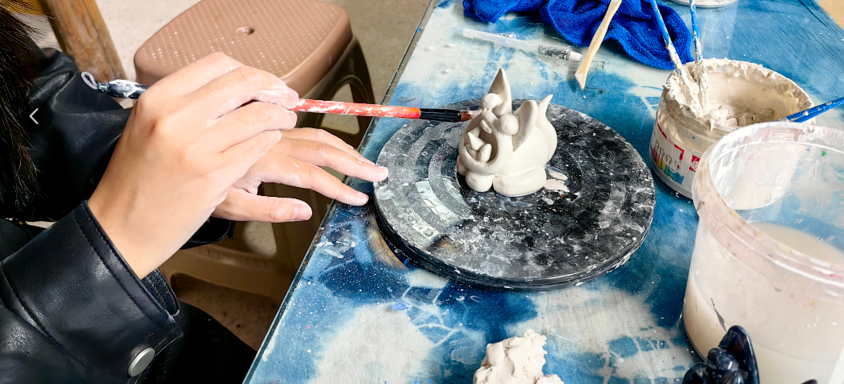

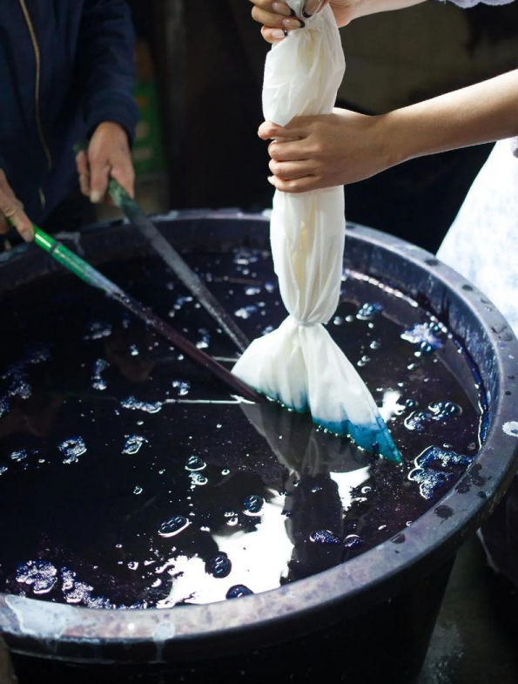 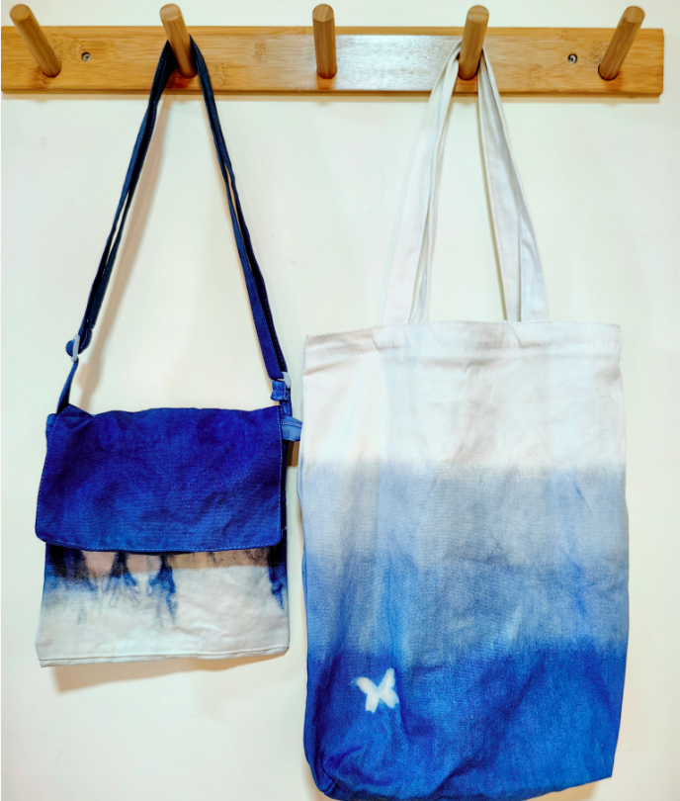

Try to turn fresh rose into cakes with local magic

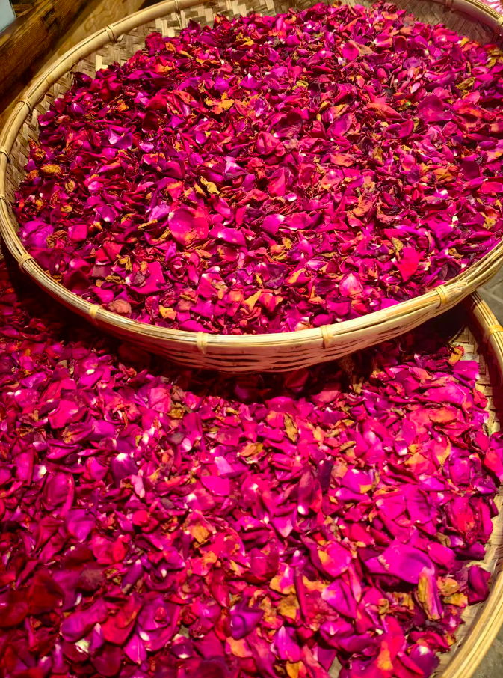 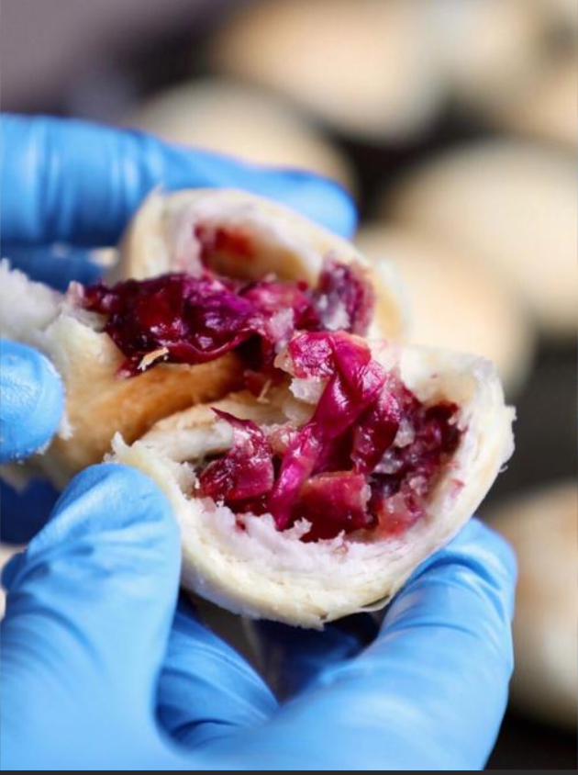

Take a stroll along the ancient streets and buildings that will take you back to the ancient Tea Horse Road

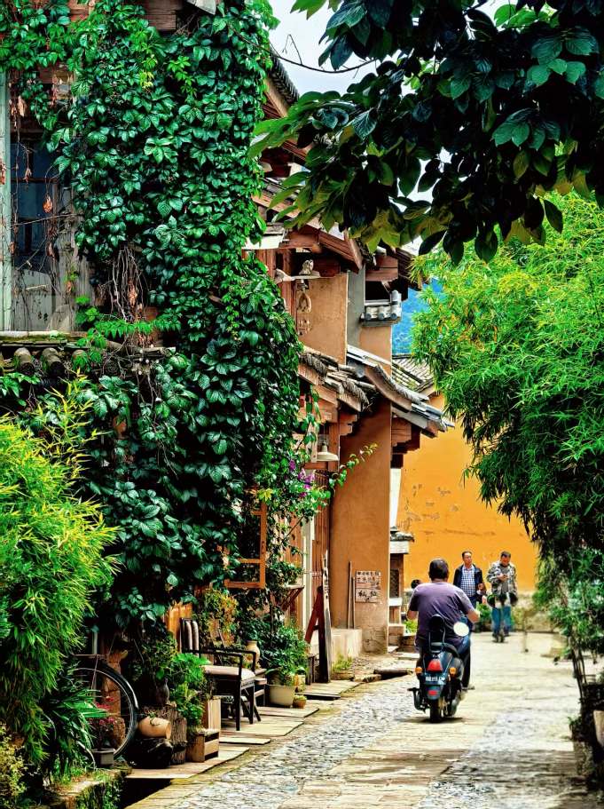 

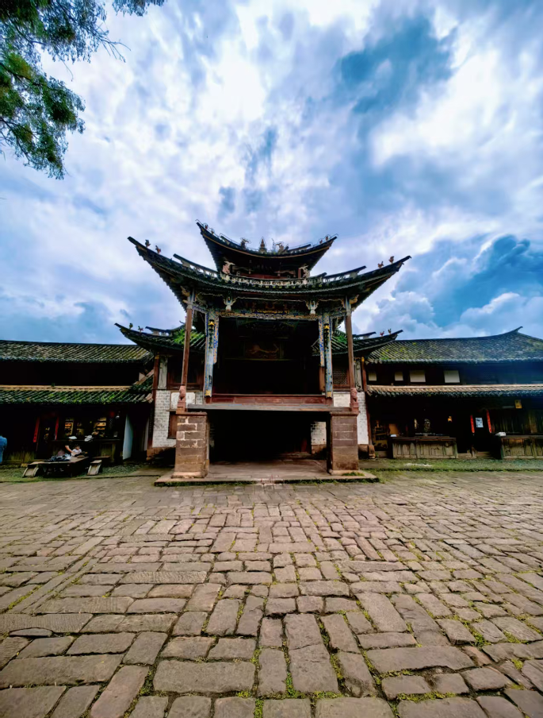 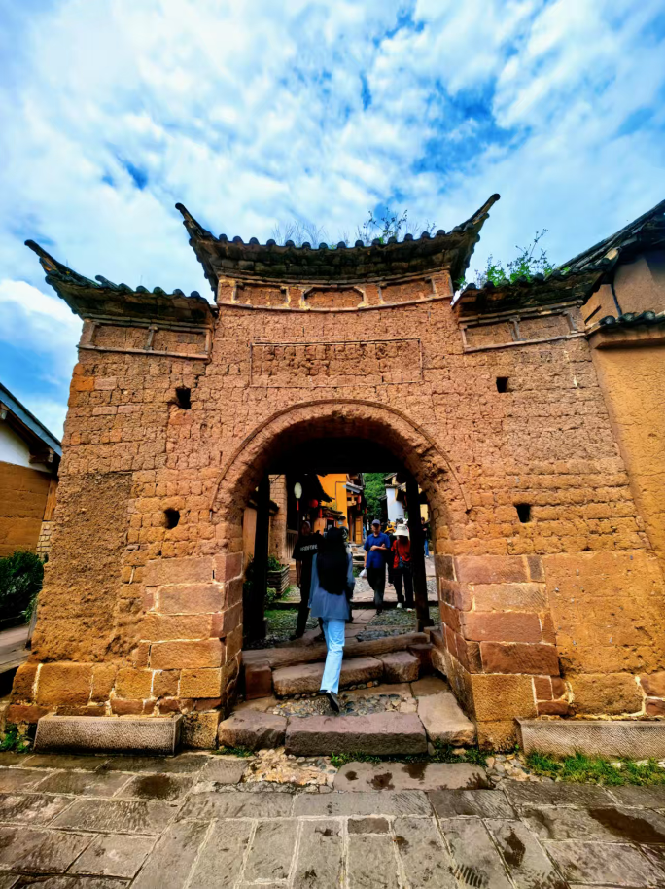

Drink a cup of coffee by the fields, feel the real peaceful life here

 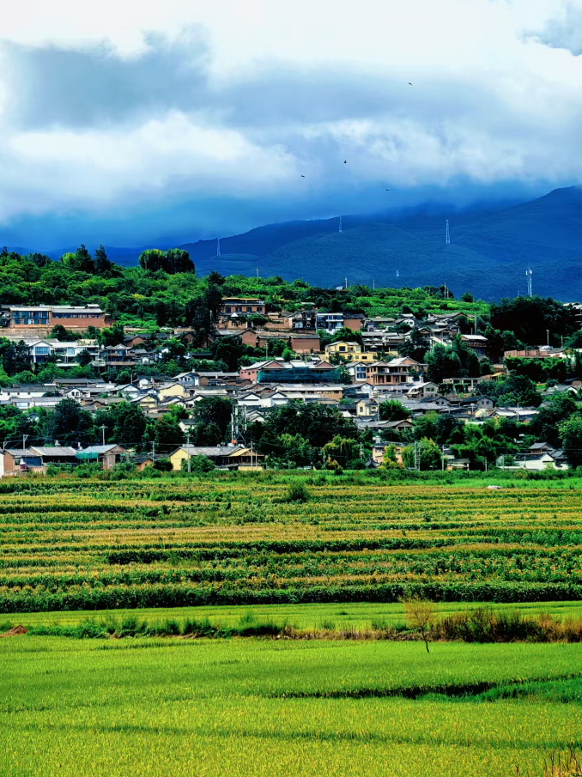

Enjoy beautiful scenery and make your heart quiet as well

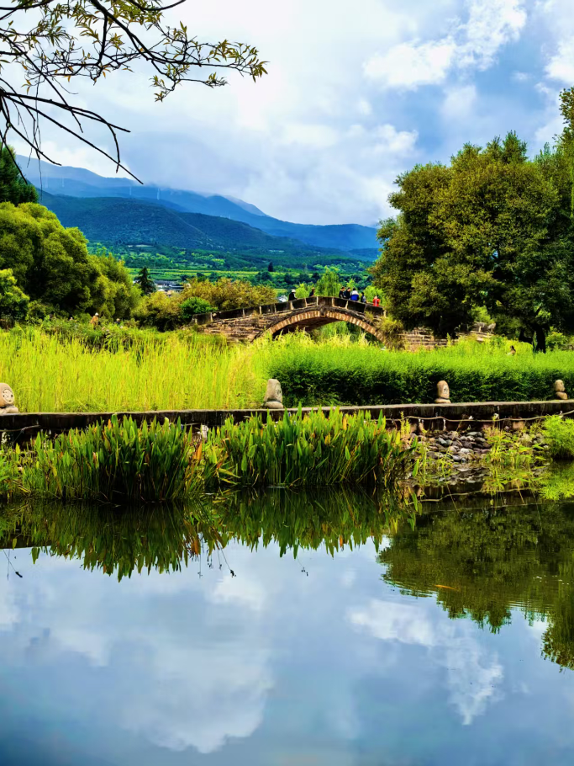 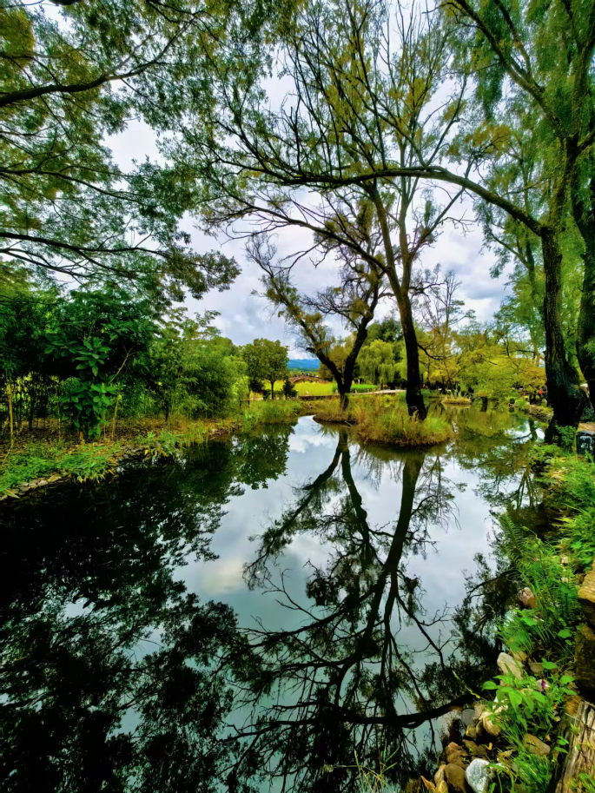

Join the weekly market, experience the local simple life

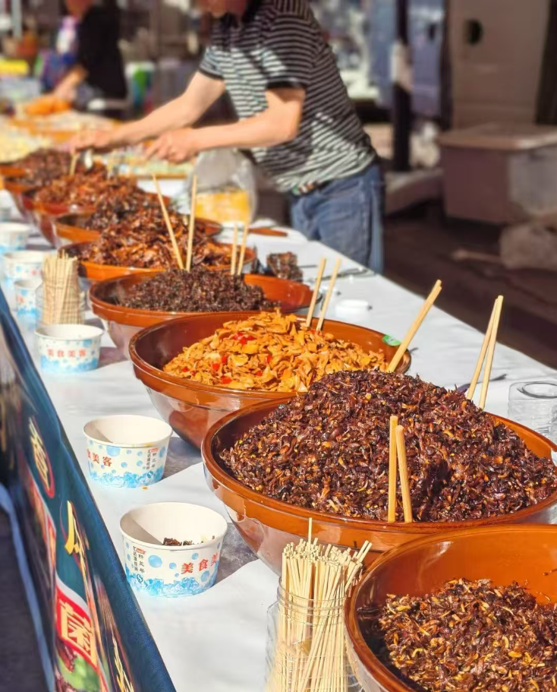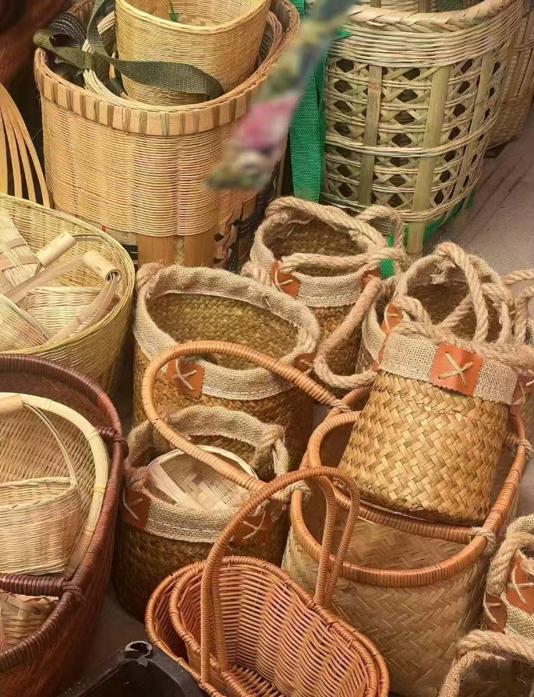

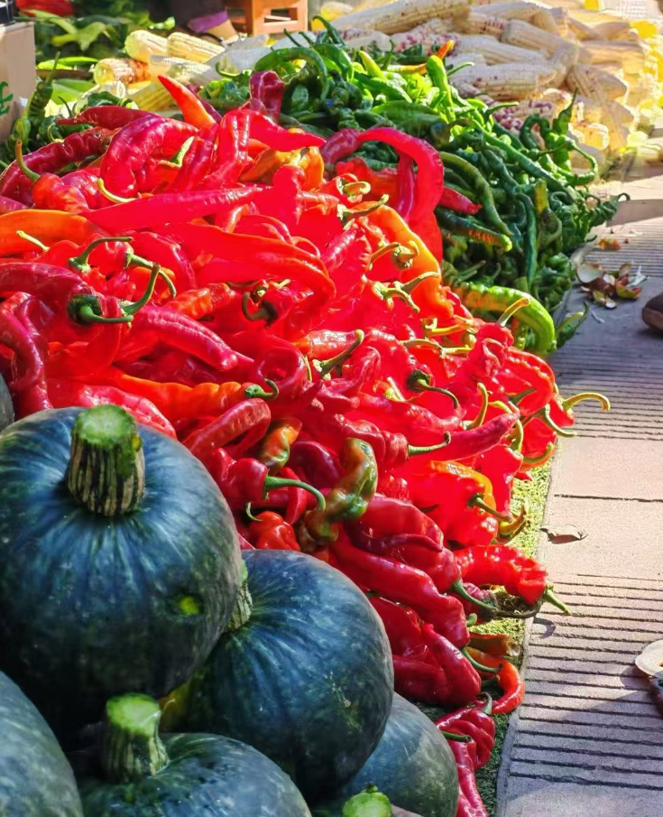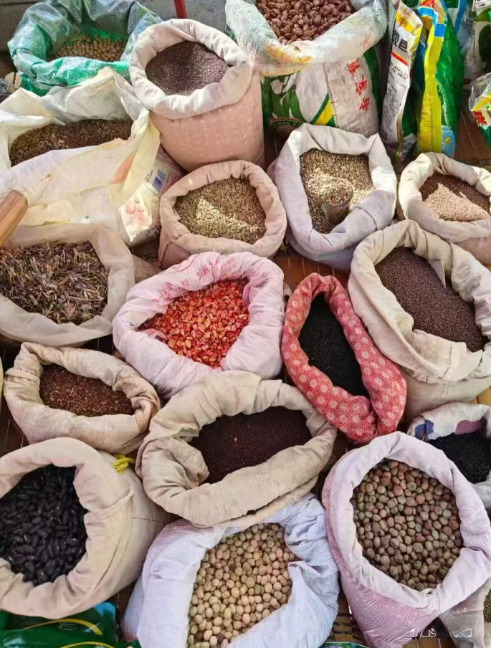

**Excellent tutors**

All tutors in our team have undergone comprehensive **training** and hold **professional** certificates，CTCSOL（Certificates for Teachers of Chinese to Speaker of Other Languages）or Teacher qualification certificate，together with **rich teaching experiences.**

They will provide you with patient, professional and targeted teaching, and solve your problems with a variety of different methods, making the lessons **interesting and practical.**

**（老师和学生一对一上课图片）**

**（这里请增加一个按键链接到导师团队）**

**More info about tutors team**

**Accommodation**

The accommodation for you is full of **local life characteristics.**

Your room is an independent room with a private bathroom, clean, tidy, **safe** and comfortable.

Free room cleaning service is offered **everyday**.

24-hour hot water, WIFI and other necessary living facilities are included.

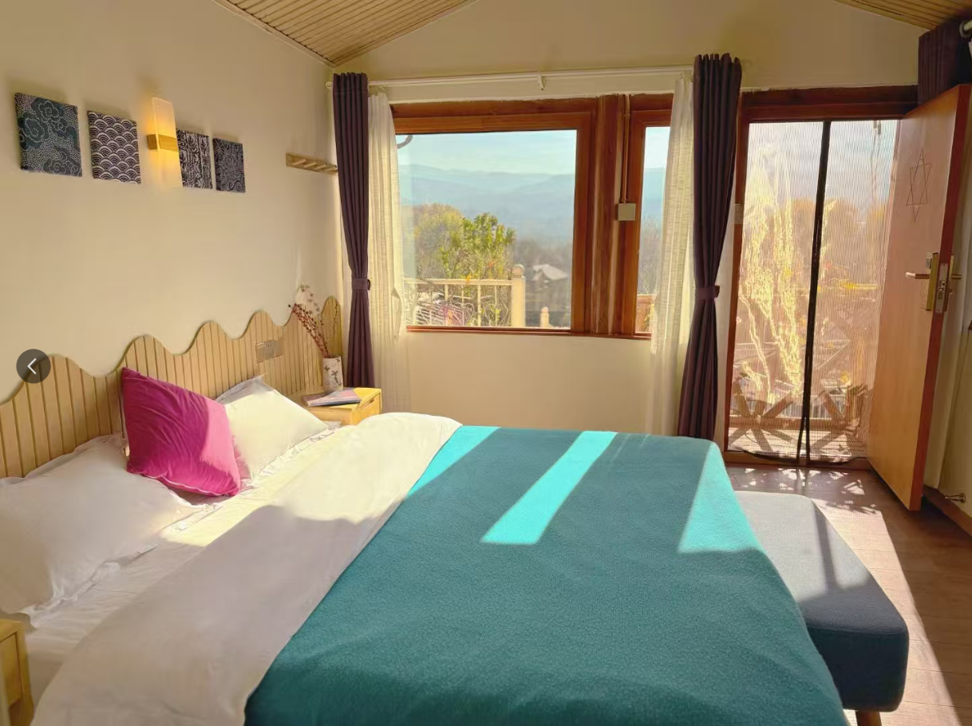 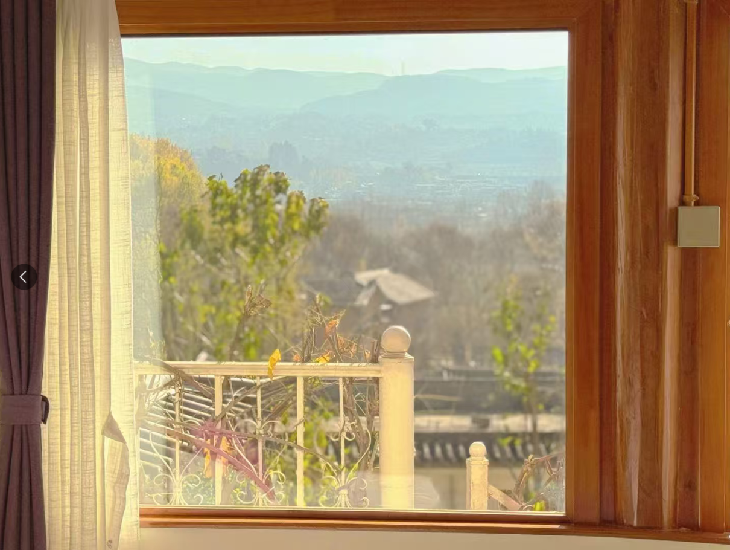

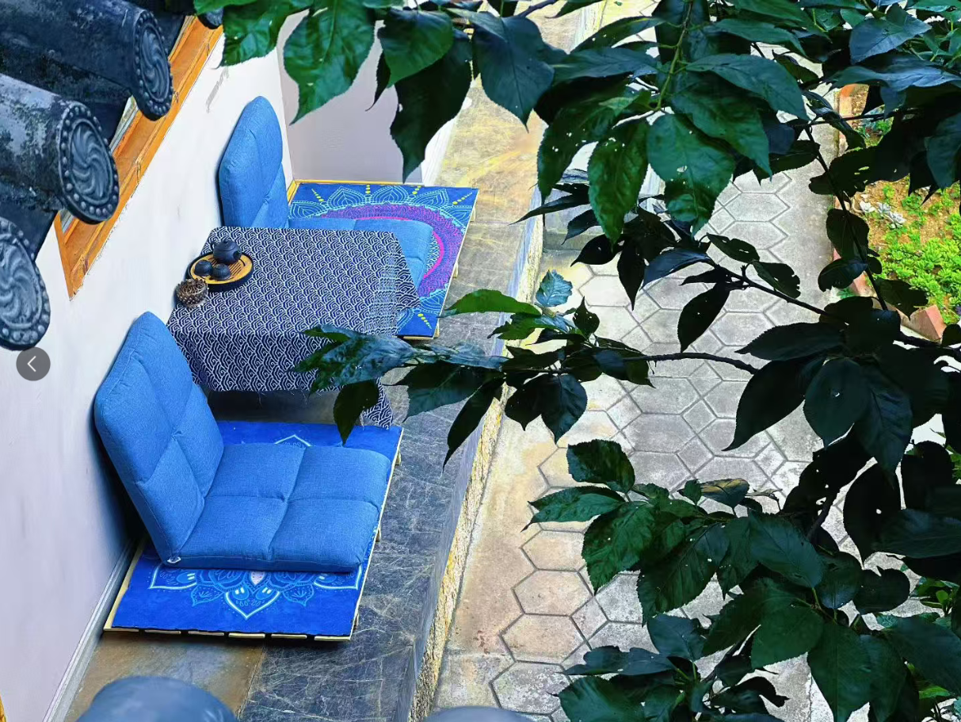 

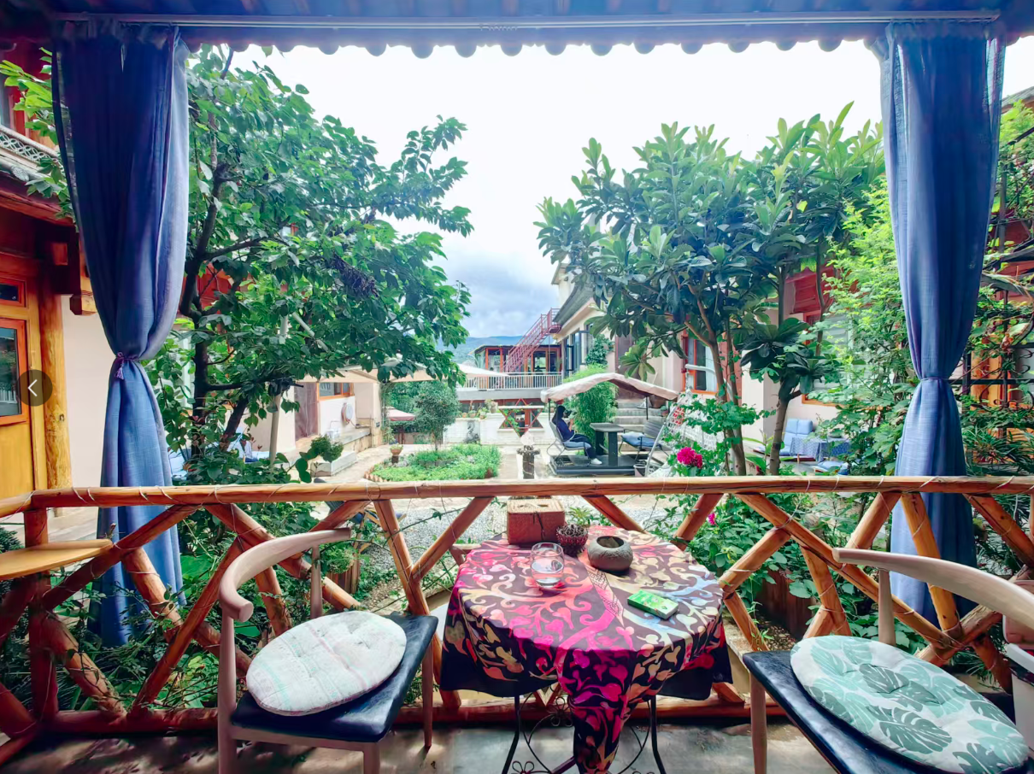 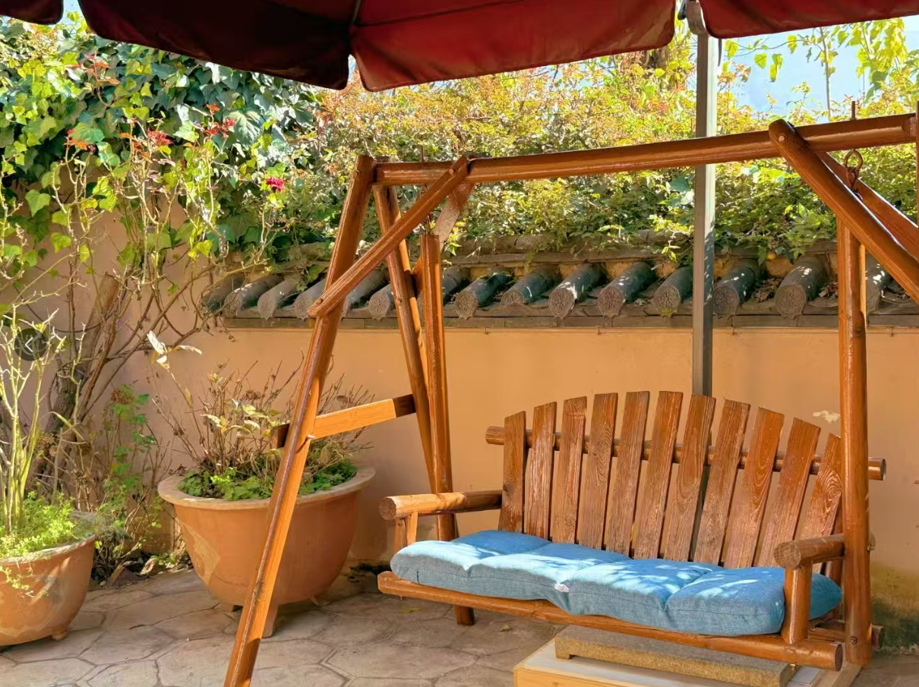

**How to get Dali Shaxi**

Dali is located in the west-central part of Yunnan and west of the provincial capital Kunming.

You can choose to get Dali by plane, by car or high-speed rail, but the most convenient way to reach Dali is of course to take the high-speed rail.



You can get provincial capital Kunming by plane first and then take the high-speed rail to Dali, we will pick you up there to beautiful Shaxi for free.

**Pricing**

**Special offer！**

4 hours per day (20 hours a week)

$1400/ week

5 hours per day (25 hours a week)

$1590 / week

6 hours per day (30 hours a week)

$1730/ week

**Ready to launch your Chinese learning journey?**

**Apply now**

The fee includes:

🗹 Personalized Chinese classes per week

🗹 Program certificate

🗹 3 meals Monday to Friday and accommodation

🗹 Kunming airport pick-up and drop-off

🗹 Pick-up and drop-off for Shaxi to Dali rail way station

🗹 Orientation

🗹 All the campus facilities

🗹 Room cleaning everyday

🗹 Free WIFI

🗹 Commonly used medicines

🗹 24/7 support

🗹 Visa support materials